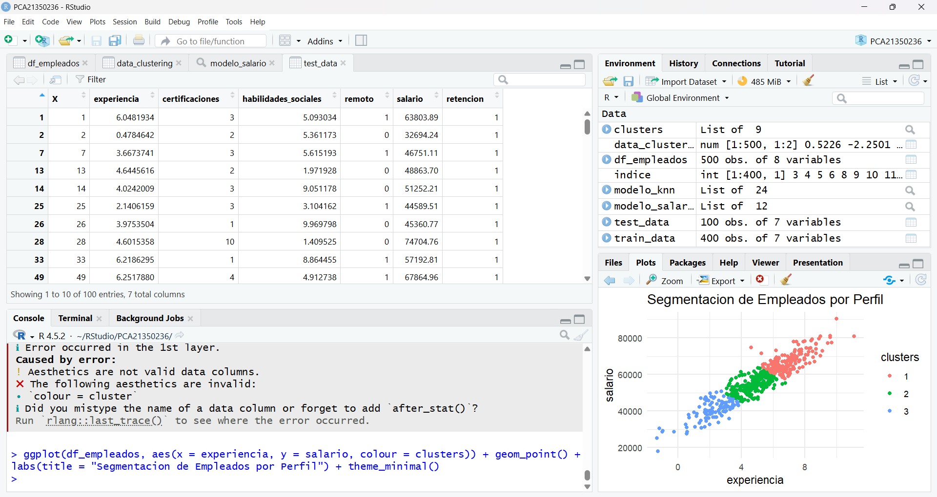
df_empleados <- read.csv(file="empleados.csv")
set.seed(123)
library(tidyverse)
library(caret)
install.packages("caret")
library(caret)
library(glmnet)
install.packages("glmnet")
library(glmnet)
indice <- createDataPartition(df_empleados$salario, p = 0.8, list = FALSE)
train_data <- df_empleados[indice,]
test_data <- df_empleados[-indice,]
modelo_salario <- lm(salario ~ experiencia + cetificaciones,data = train_data)
modelo_salario <- lm(salario ~ experiencia + certificaciones,data = train_data)
summary(modelo_salario)
summary(modelo_salario)
modelo_knn <- train(retencion ~ experiencia + habilidades_sociales + salario, data = train_data, method = "knn", preProcess = c("center", "scale"), tuneLength)
library(tidyverse)
library(caret)
modelo_knn <- train(retencion ~ experiencia + habilidades_sociales + salario, data = train_data, method = "knn", preProcess = c("center", "scale"), tuneLength)
library(glmnet)
modelo_knn <- train(retencion ~ experiencia + habilidades_sociales + salario, data = train_data, method = "knn", preProcess = c("center", "scale"), tuneLength)
modelo_knn <- train(retencion ~ experiencia + habilidades_sociales + salario, data = train_data, method = "knn", preProcess = c("center", "scale"), tuneLength = 5)
train_data$retencion <- as.factor(train_data$retencion)
modelo_knn <- train(retencion ~ experiencia + habilidades_sociales + salario, data = train_data, method = "knn", preProcess = c("center", "scale"), tuneLength = 5)
data_clustering <- df_empleados %>% select(experiencia,salario) %>% scale()
set.seed(456)
clusters <- kmeans(data_clustering, centers = 3)
df_empleados$clusters <- as.factor(clusters$cluster)
view(df_empleados)
ggplot(df_empleados, aes(x = experiencia, y = salario))
ggplot(df_empleados, aes(x = experiencia, y = salario, colour = cluster)) + geom_point() + labs(title = "Segmentacion de Empleados por Perfil") + theme_minimal()
ggplot(df_empleados, aes(x = experiencia, y = salario, color = cluster)) + geom_point() + labs(title = "Segmentacion de Empleados por Perfil") + theme_minimal()
ggplot(df_empleados, aes(x = experiencia, y = salario, colour = clusters)) + geom_point() + labs(title = "Segmentacion de Empleados por Perfil") + theme_minimal()
View(clusters)
View(data_clustering)
View(modelo_salario)
View(test_data)
ggplot(df_empleados, aes(x = experiencia, y = salario, colour = cluster)) + geom_point() + labs(title = "Segmentacion de Empleados por Perfil") + theme_minimal()
ggplot(df_empleados, aes(x = experiencia, y = salario, colour = cluster)) + geom_point() + labs(title = "Segmentacion de Empleados por Perfil") + theme_minimal()
ggplot(df_empleados, aes(x = experiencia, y = salario, colour = clusters)) + geom_point() + labs(title = "Segmentacion de Empleados por Perfil") + theme_minimal()
history()
savehistory("~/RStudio/PCA21350236/p2.txt")

